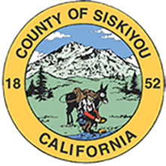

SISKIYOU COUNTY

GROUNDWATER WELL APPLICATION PROCESS

GUIDELINES

2024

# I. Purpose

These Guidelines are informational in nature. They have been prepared to explain to permit applicants the various authorities that currently impact the Department of Environmental Health’s processing of well applications and to guide applicants in completing the well application process.

# II. Authority

**WATER WELL STANDARDS**

In California, permitting authority over well drilling activities rests with the local well permitting agency. In Siskiyou County, the permitting agency is the Siskiyou County Department of Environmental Health. Environmental Health permits both domestic and production wells pursuant to Chapter 8, Title 5 of the Siskiyou County Code. The California Department of Water Resources developed well standards to protect groundwater quality, including protection against adverse effects caused by improper well construction or abandonment of wells, as published in the “California Well Standards – Bulletin 74-81”[1] (“Bulletin”). The Siskiyou County Code incorporates the standards set forth in the Bulletin.

**EXECUTIVE ORDER**

On March 28, 2022, Governor Gavin Newsom signed Executive Order N-7-22 (“Executive Order”) in response to extreme and expanding drought conditions, which prohibits Environmental Health from issuing a construction permit for a new (or replacement) groundwater well or for alteration / modification of an existing groundwater well pursuant to Chapter 8, Title 5 of the Siskiyou County Code unless certain requirements are met or the permit falls within the limited exception to the requirements. On February 13, 2023, Governor Newsom signed Executive Order N-3-23, which revised Paragraph 9 of Executive Order N-7-22 to read as follows:

*To protect health, safety, and the environment during this drought emergency, a county, city, or other public agency shall not:*

*a. Approve a permit for a new groundwater well or for alteration of an existing well in a basin subject to the Sustainable Groundwater Management Act and classified as medium- or high-priority without first obtaining written verification from a Groundwater Sustainability Agency managing the basin or area of the basin where the well is proposed to be located that groundwater extraction by the proposed well would not be inconsistent with any sustainable groundwater management program established in any applicable Groundwater Sustainability Plan adopted by that Groundwater Sustainability Agency and would not decrease the likelihood of achieving a sustainability goal for the basin covered by such a plan; or*

*b. Issue a permit for a new groundwater well or for alteration of an existing well without first determining that extraction of groundwater from the proposed well is (1) not likely to interfere with the production and functioning of existing nearby wells, and (2) not likely to cause subsidence that would adversely impact or damage nearby infrastructure.*

*This Paragraph shall not apply to permits for wells (i) that will provide less than two acre-feet per year of groundwater for individual domestic users, (ii) that will exclusively provide groundwater to public water supply systems as defined in section 116275 of the Health and Safety Code, or (iii) that are replacing existing, currently permitted wells with new wells that will produce an equivalent quantity of water as the well being replaced when the existing well is being replaced because it has been acquired by eminent domain or acquired while under threat of condemnation.*

A complete copy of the Executive Order N-7-22 is available here: <https://www.gov.ca.gov/wp-content/uploads/2022/03/March-2022-Drought-EO.pdf> (see Paragraph 9). A complete copy of Executive Order N-3-23 is available here: <https://www.gov.ca.gov/wp-content/uploads/2023/02/Feb-13-2023-Executive-Order.pdf>.

**PUBLIC TRUST DOCTRINE**

The Third District Court of Appeal has found that the common law Public Trust Doctrine applies to the County’s issuance of well construction permits in the Scott Valley watershed. Under this doctrine, the County, as a political subdivision of the state, considers impacts to public trust resources in the Scott River -- such as navigation, recreation, and fisheries -- whenever the County issues a permit for a new well that, through the extraction of groundwater interconnected with the Scott River’s surface waters, may substantially impair the Scott River’s public trust resources. The Board of Supervisors has adopted a resolution making standardized public trust findings for domestic and stock wells in the Scott Valley that deliver two acre-feet of groundwater per year or less on property under the same ownership as the parcel on which the well is located.

Per Board direction, the County’s consideration of the Public Trust Doctrine has been extended to well permitting in the Shasta Valley.

As additional hydrological data is obtained in other areas of the County, the County’s consideration of the Public Trust Doctrine will extend to those areas for which hydrological data evidences the presence of groundwater interconnected with navigable surface waters.

The state of California, as trustee, holds all navigable water ways in trust for the benefit of the public and has the duty to protect these waterways.[2] The State, through the State Water Resources Control Board (SWRCB), took action to protect public trust resources in the Scott River and the Shasta River by adopting and implementing emergency curtailment regulations from August 2021 to August 2023. Through those curtailment regulations, SWRCB established a priority list of water rights and users, which in some cases prohibit and/or restrict groundwater pumping by well owners in the Shasta Valley and Scott Valley when necessary to help maintain minimum instream flows to protect multiple fish species and the environment. On December 19, 2023, the SWRCB adopted a new emergency regulation for the Scott and Shasta River Watersheds. The Office of Administrative Law approved the emergency regulation on February 1, 2024 and it is in effect for one year, unless re-adopted or rescinded.

**CALIFORNIA ENVIRONMENTAL QUALITY ACT**

On August 27, 2020, in *Protecting Our Water and Environmental Resources v. County of Stanislaus*, the California Supreme Court held that Stanislaus County could not categorically classify its issuance of groundwater well construction permits as ministerial decisions exempt from environmental review under the California Environmental Quality Act (“CEQA”) (Pub. Resources Code, §§ 21000 et seq.); however, the permit approvals might still be ministerial “[i]f the circumstances of a particular project do not require the exercise of independent judgment”.

Domestic and stock water well permitting under 2 acre feet per year is generally presumed to be ministerial for most projects. Permit approval for production wells will be determined on a case-by-case basis and depending on the circumstances of the particular project may be subject to CEQA review.

These Guidelines explain Environmental Health’s application process in the context of the above authorities.

# III. Implementation: Well Standards

Water Well Construction Standards for the State of California are provided in

Department of Water Recourses Bulletin 74-81 and Siskiyou County Ordinance Chapter 8 title 5 of the Siskiyou Code. Domestic wells that utilize less than two-acre feet per year will be issued ministerial permits subject to basic setback requirements. Production wells will be subject to joint review by the Siskiyou County Natural Resources Department and the Environmental Health Division.

# IV. Implementation: Executive Order

**Applications for Exempt Domestic and Public Wells: Declaration Required.**

The requirements of Executive Order N-7-22 (at Paragraph 9), as revised by Executive Order N-3-23, do not apply to permits for wells that will provide **less than two (2) acre-feet per year** of groundwater **for individual domestic users** or that will exclusively provide groundwater to public water supply systems as defined in Health and Safety Code Section 116275 (“Exempt Well(s)”).

If a water well construction permit application for a new groundwater well or for alteration of an existing groundwater well is signed by the well owner and identifies the “intended use” in the “well proposal details” as “domestic,” Environmental Health will treat the permit as exempt from the requirements of the Executive Order.

If a water well construction permit application for a new groundwater well or for alteration of an existing groundwater well is signed by the well owner and identifies the “intended use” in the “well proposal details” as “public / community water system,” Environmental Health will treat the permit as exempt from the requirements of the Executive Order.

**Applications for Non-Exempt Wells**

**Stock Water Wells Countywide: Environmental Health Determination**

A stock water well, for the purposes of this guideline document, is any well that will deliver less than 2-acre feet of groundwater for the purpose of providing drinking water to livestock and other on-farm animals. Regardless of the well’s location, the water well construction permit application for a new or altered **stock water groundwater well** will required an in-house Environmental Health determination that both the extraction of groundwater from the well (1) “is not likely to interfere with the production and functioning of existing nearby wells” and (2) “is not likely to cause subsidence that would adversely impact or damage nearby infrastructure.” (See Paragraph 9(b) of the Executive Order N-7-22, as modified by Executive Order N-3-23).

**Production Wells Countywide: Licensed Professional Geologist Report Required.**

A production groundwater well, for the purposes of this guideline document, is considered any well for agricultural or industrial use that will deliver 2 acre feet or more of groundwater per year. Regardless of the well’s location, the water well construction permit application for a new or altered **production groundwater well** must be accompanied by a report signed by a California licensed Professional Geologist that concludes both that extraction of groundwater from the well (1) “is not likely to interfere with the production and functioning of existing nearby wells” and (2) “is not likely to cause subsidence that would adversely impact or damage nearby infrastructure.” (See Paragraph 9(b) of the Executive Order N-7-22, as modified by Executive Order N-3-23).

Applications shall also be accompanied by the base application fee, and any applicable CEQA review fees.

**Stock Wells and Production Wells in SGMA Basins: Verification from Groundwater Sustainability Agency Required.**

Environmental Health will not issue a water well construction permit for a new or altered stock or production groundwater well located within the Scott Valley Groundwater Subbasin, the Shasta Valley Groundwater Subbasin, the Butte Valley Groundwater Subbasin, or the Tule Lake Groundwater Subbasin (as identified by the Department of Water Resources) without first obtaining from the relevant **Groundwater Sustainability Agency[3]** the **verification** required by Paragraph 9(a) of the Executive Order (**in addition to the report described above**).

In addition to the fees that are described above, applications for production wells in SGMA basins shall also be accompanied by any SGMA Basin review fee imposed on Environmental Health by the relevant Groundwater Sustainability Agency, which is directly passed through to the applicant.

The requirements of this Section IV will be observed until the Executive Order is lifted.

# V. Implementation: Public Trust Doctrine

**Scott River and Shasta River Watersheds:**

**Production Wells**

In May of 2021, Larry Walker Associates (LWA) introduced the Siskiyou County

Board of Supervisors and the public to a hydrologic modeling tool that LWA developed to inform individual well permitting decisions in the Scott Valley and to help the Environmental Health Division evaluate potential public trust impacts to the Scott River. For wells that fall outside of the domestic and stock wells addressed in the Board’s resolution making standardized public trust findings, the Environmental Health Division intends to use LWA’s modeling tool to make findings on whether the pumping from a proposed well site in its reasonably foreseeable volumes and seasons will substantially impair or interfere with any public trust uses or values within interconnected downstream navigable waters, including the Scott River.[4]

LWA has also developed the Shasta Watershed Groundwater Model (SWGM) v 1.0, which is an evolving, integrated hydrological model that represents the entire Shasta Valley watershed. It is a preliminary effort to characterize the Shasta River watershed and will be used to inform individual well permitting decisions on production wells in the Shasta Valley and to help the Environmental Health Division evaluate potential public trust impacts to the Shasta River.

In addition to the other fees referenced under Section V. above, applicants for production wells in the Shasta Valley or Scott Valley shall be financially responsible for the actual cost to the County of LWA’s application of its hydrologic modeling tools to a proposed well site.

**Domestic and Stock Wells Delivering 2 Acre-Feet or Less**

In January of 2022, the Board adopted public trust findings related to well permitting in the Scott Valley. These findings were set forth in a resolution (see Attachment 3), which found domestic and stock well pumping from existing and future well sites delivering 2 acre-feet or less in the Scott Valley watershed will not substantially impair or interfere with public trust uses or values within interconnected downstream navigable waters, including the Scott River. These findings are attached to and relied upon for well applications in the Scott Valley wherein applicants represent the intended use of the well is for two acre-feet of groundwater per year or less for domestic or stock water use specifically for watering stock.

The form of these findings are a template for Environmental Health’s consideration of domestic and stock wells delivering 2 acre-feet or less at well sites in the Shasta River watershed.

As additional hydrological data is obtained in other areas of the County, the County’s

consideration of the Public Trust Doctrine will extend to those areas for which hydrological data evidences the presence of groundwater interconnected with surface waters.

**Countywide:**

**VI. Implementation: CEQA**

Domestic wells and stock water well permitting for wells that deliver less than 2 acre feet per year are presumed to be ministerial for most projects. Permit approval for production wells will be determined on a case-by-case basis. Below is a visual flow chart that sets forth the well permitting CEQA process for the approval or denial of a discretionary well permit.

DISCRETIONARY PERMIT PROCESS

# ATTACHMENT 1

## Groundwater Well Permitting Guidelines

**Pre-Application Checklist**

* Well Permit Application is complete and accurate – including Plot Plan, with specific distances to potential contamination sources clearly labeled.
* Fees are included- if applicable.
* A letter from a Hydrogeologist is included – if applicable.
* Any additional data required is submitted.

# ATTACHMENT 2

## Groundwater Well Permitting Guidelines

**

# ATTACHMENT 3

## Resolution No. 22-07

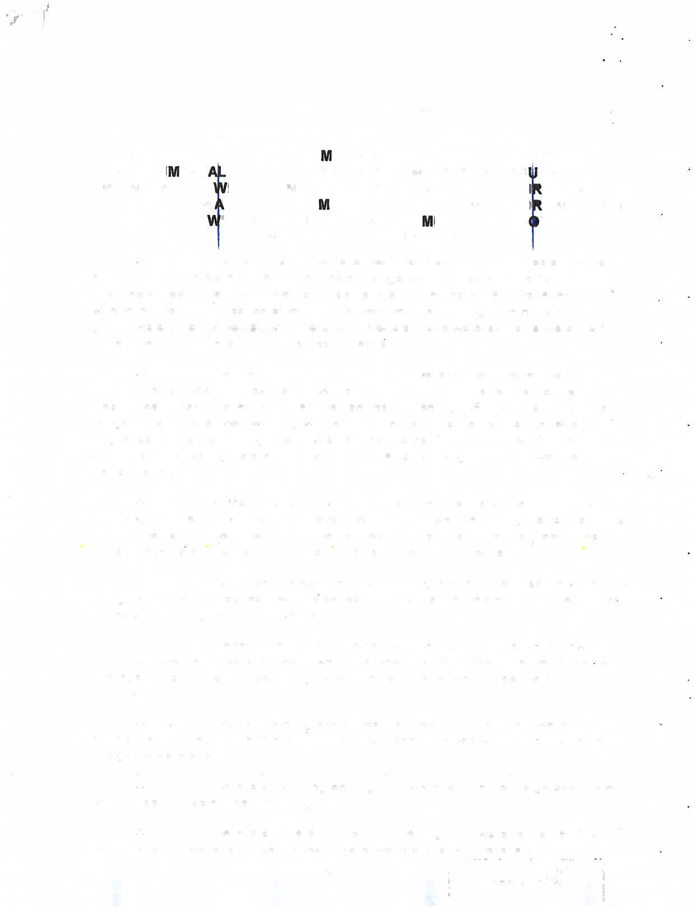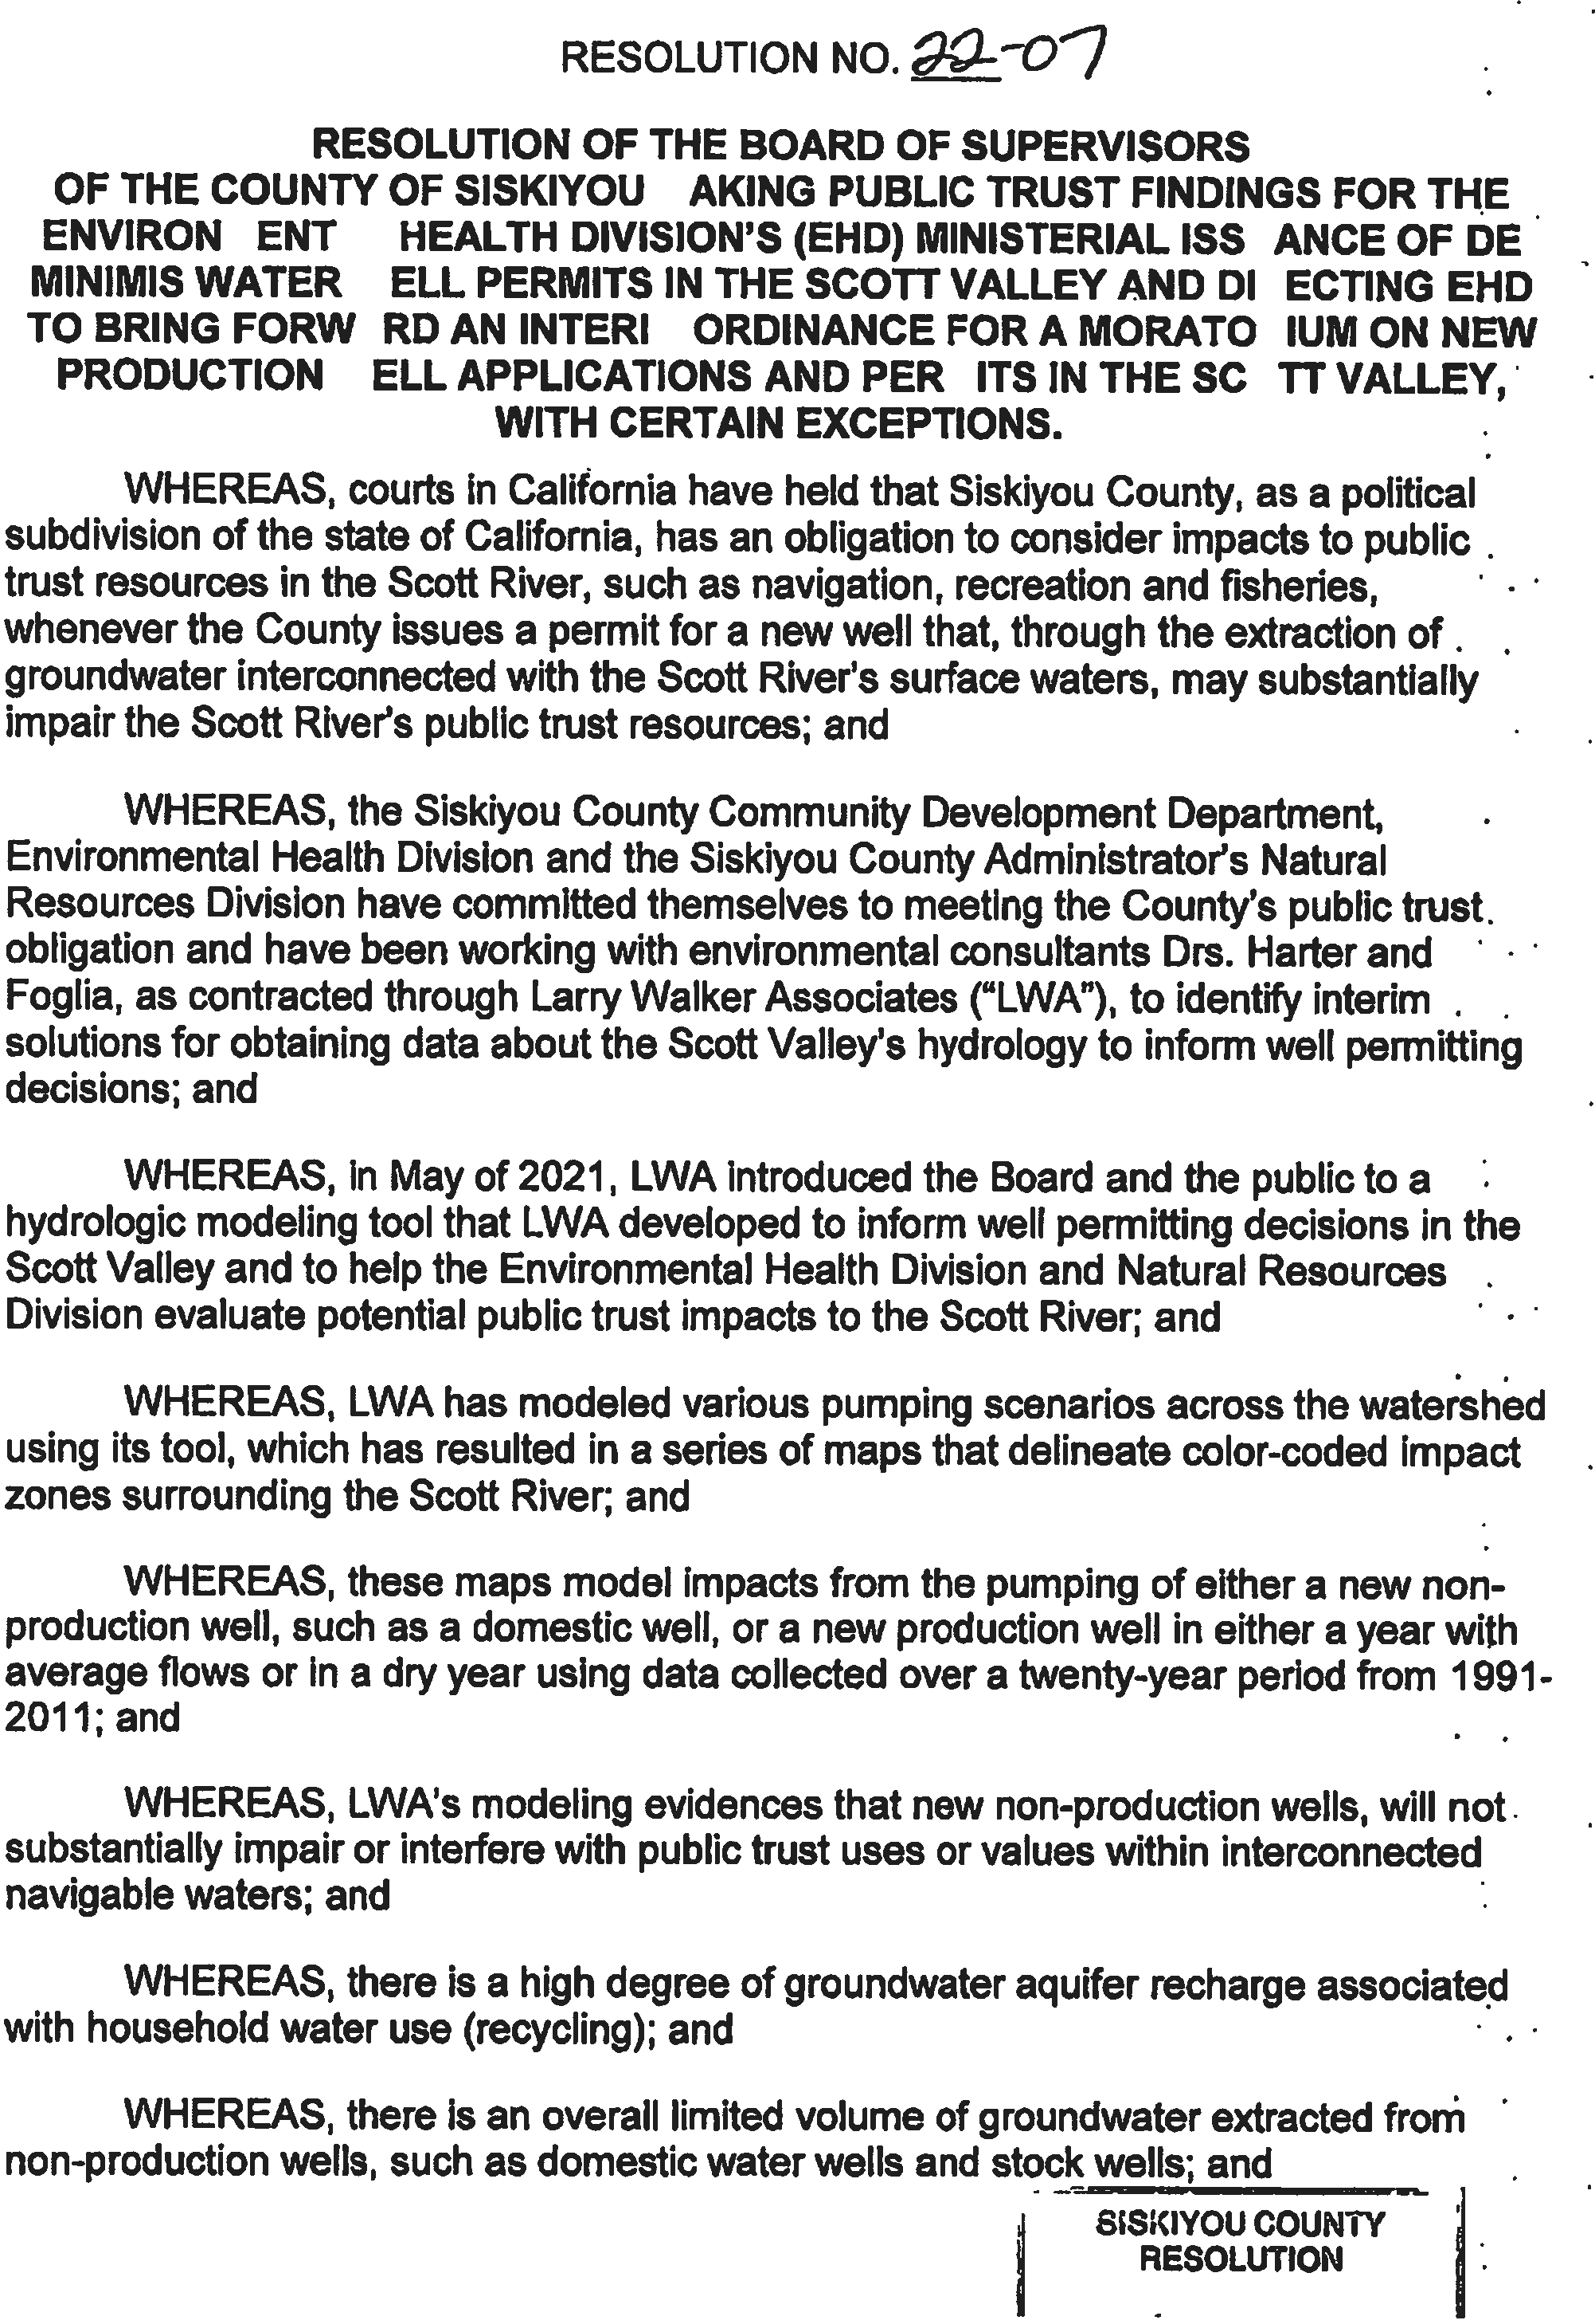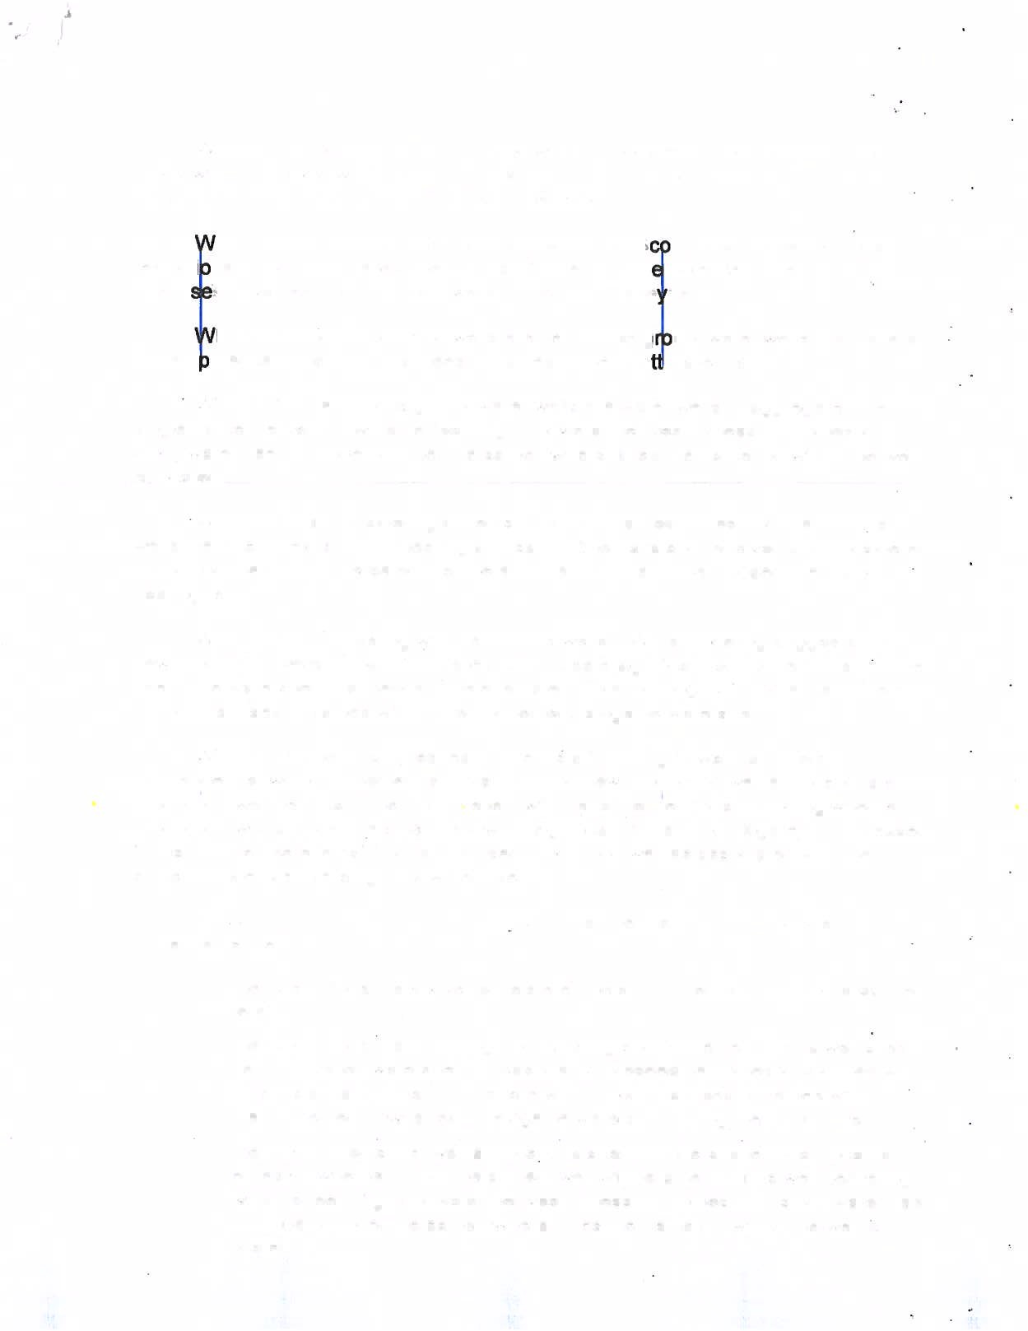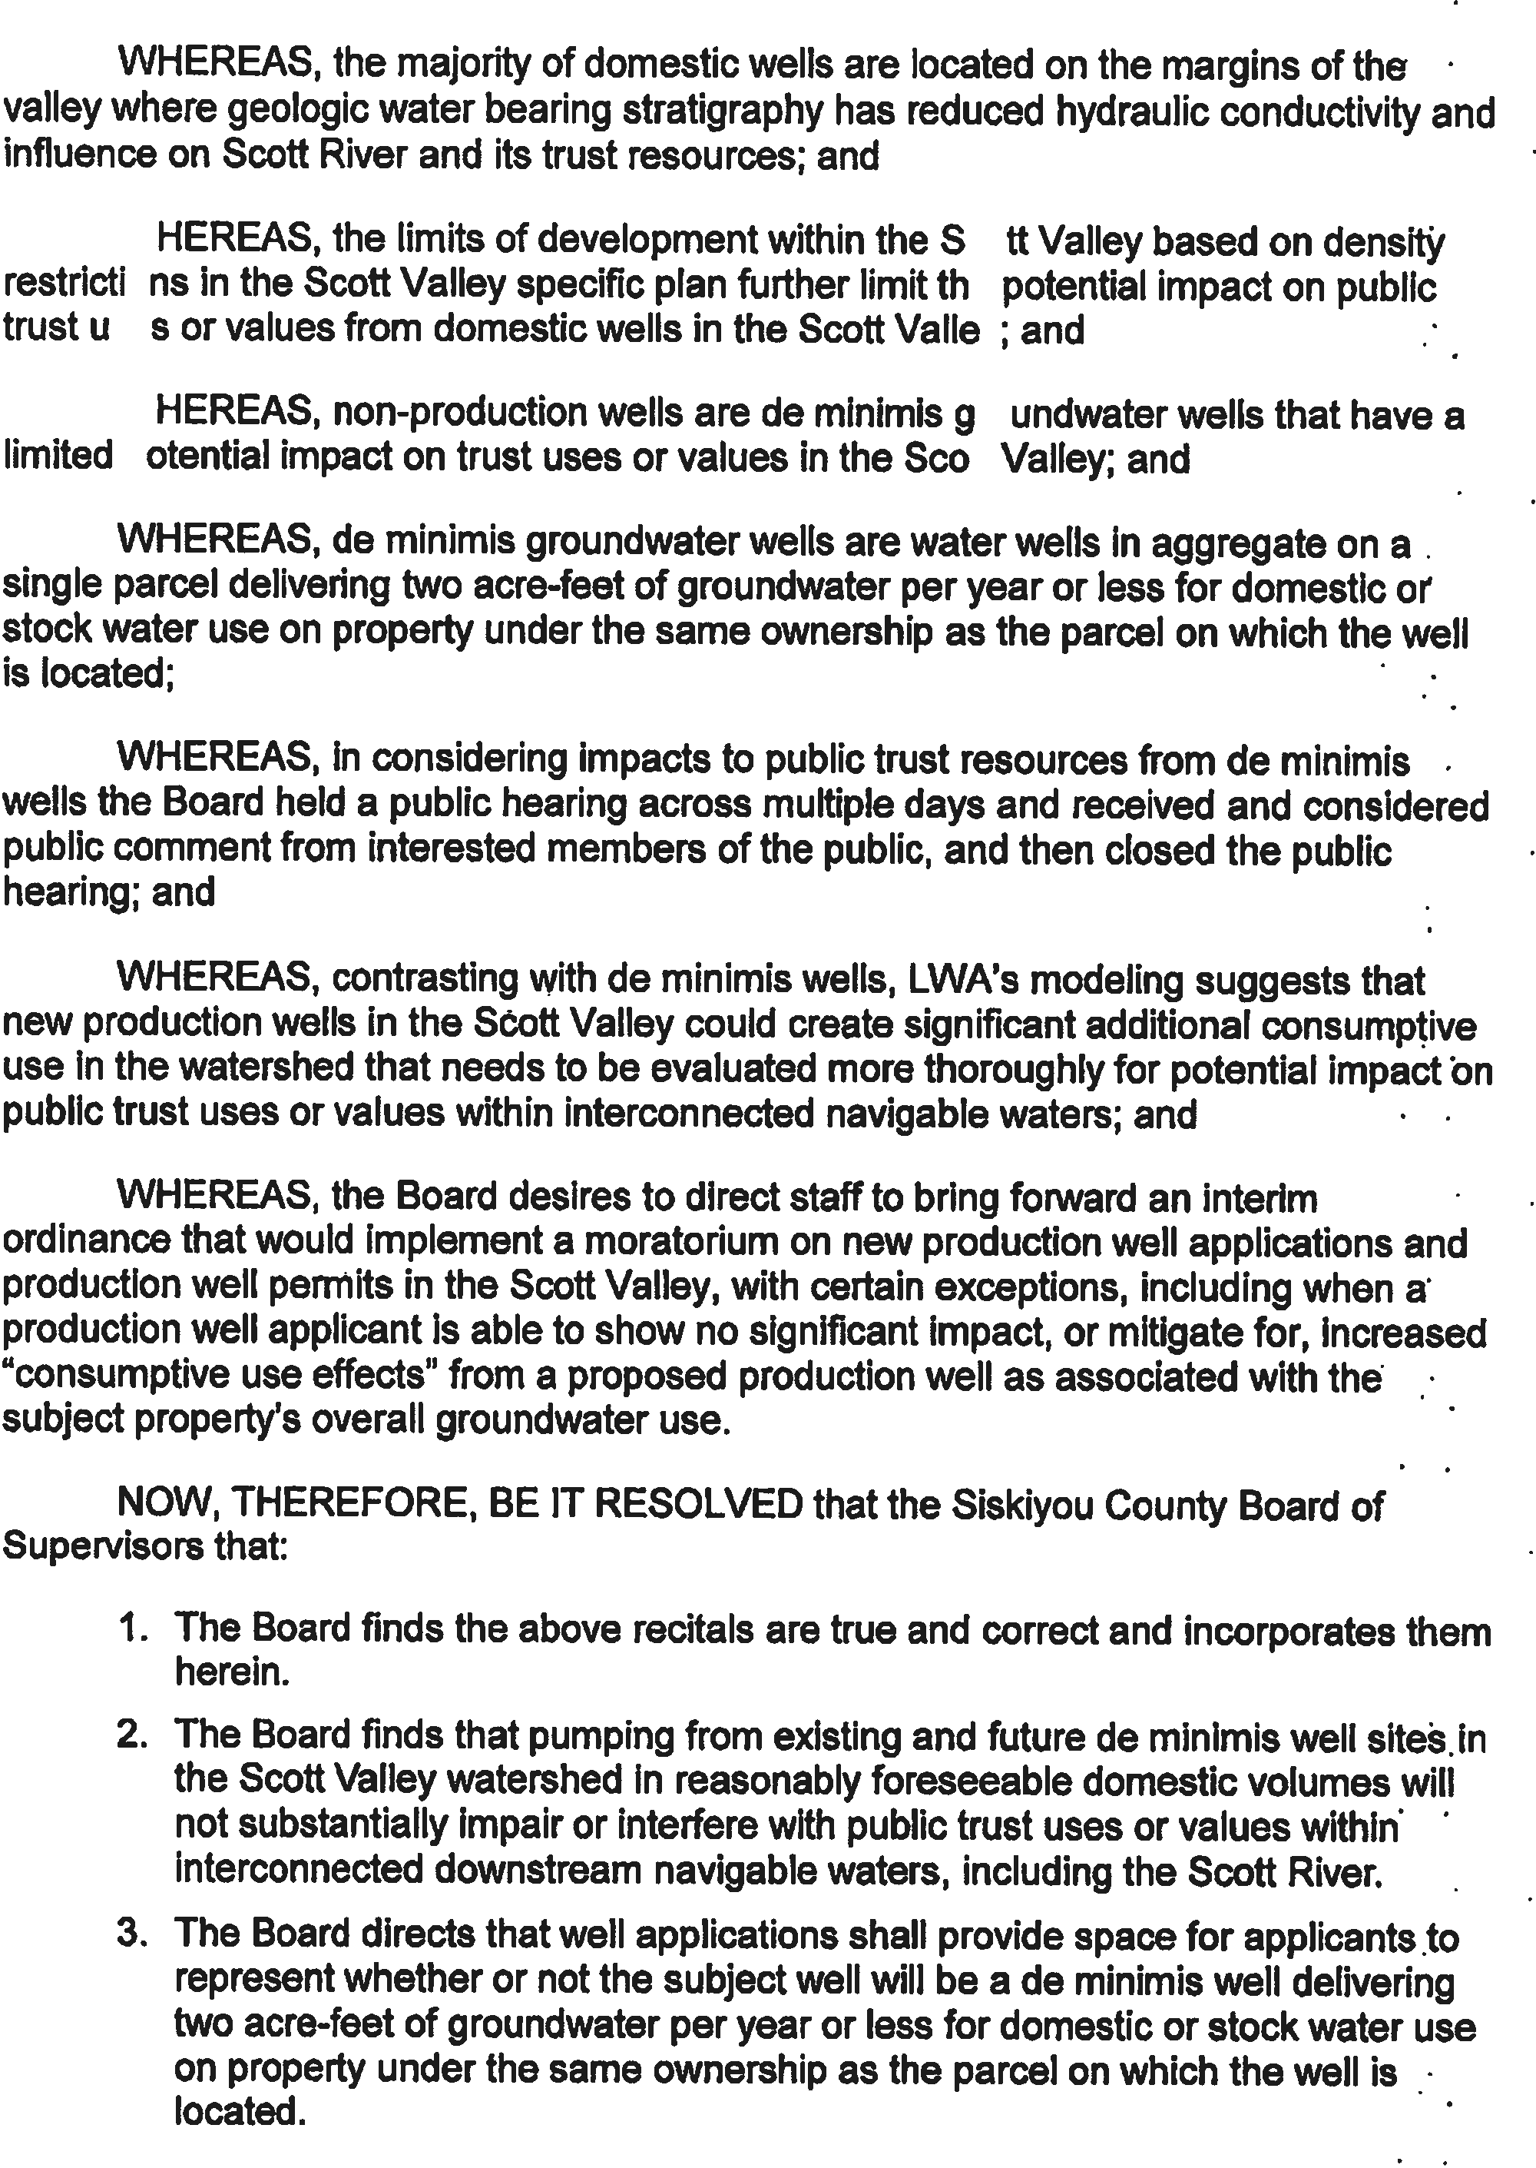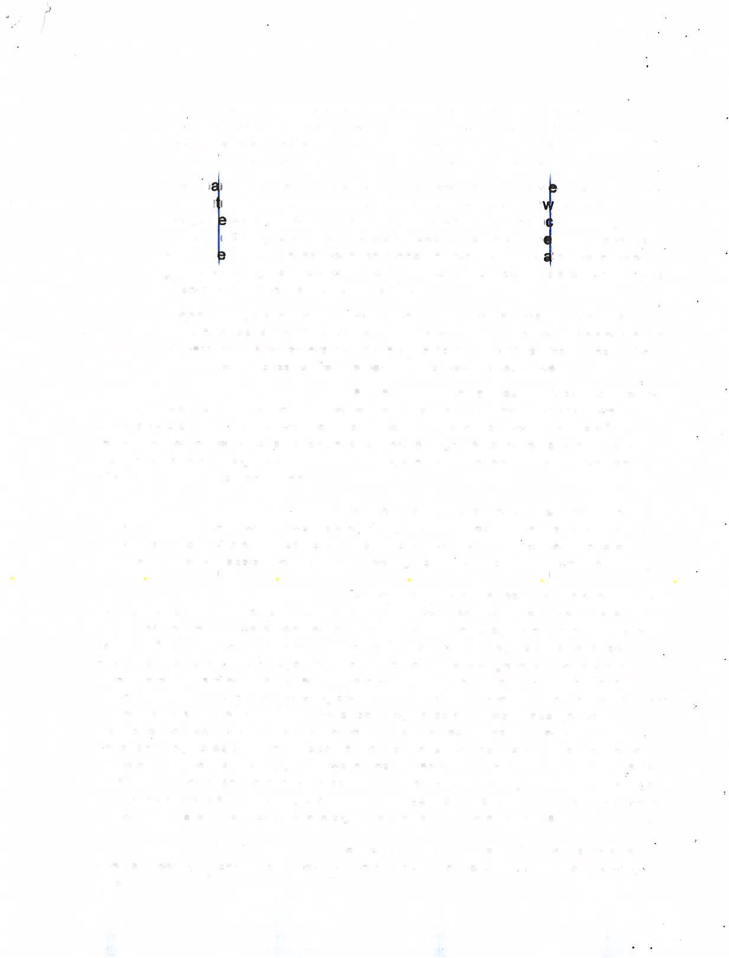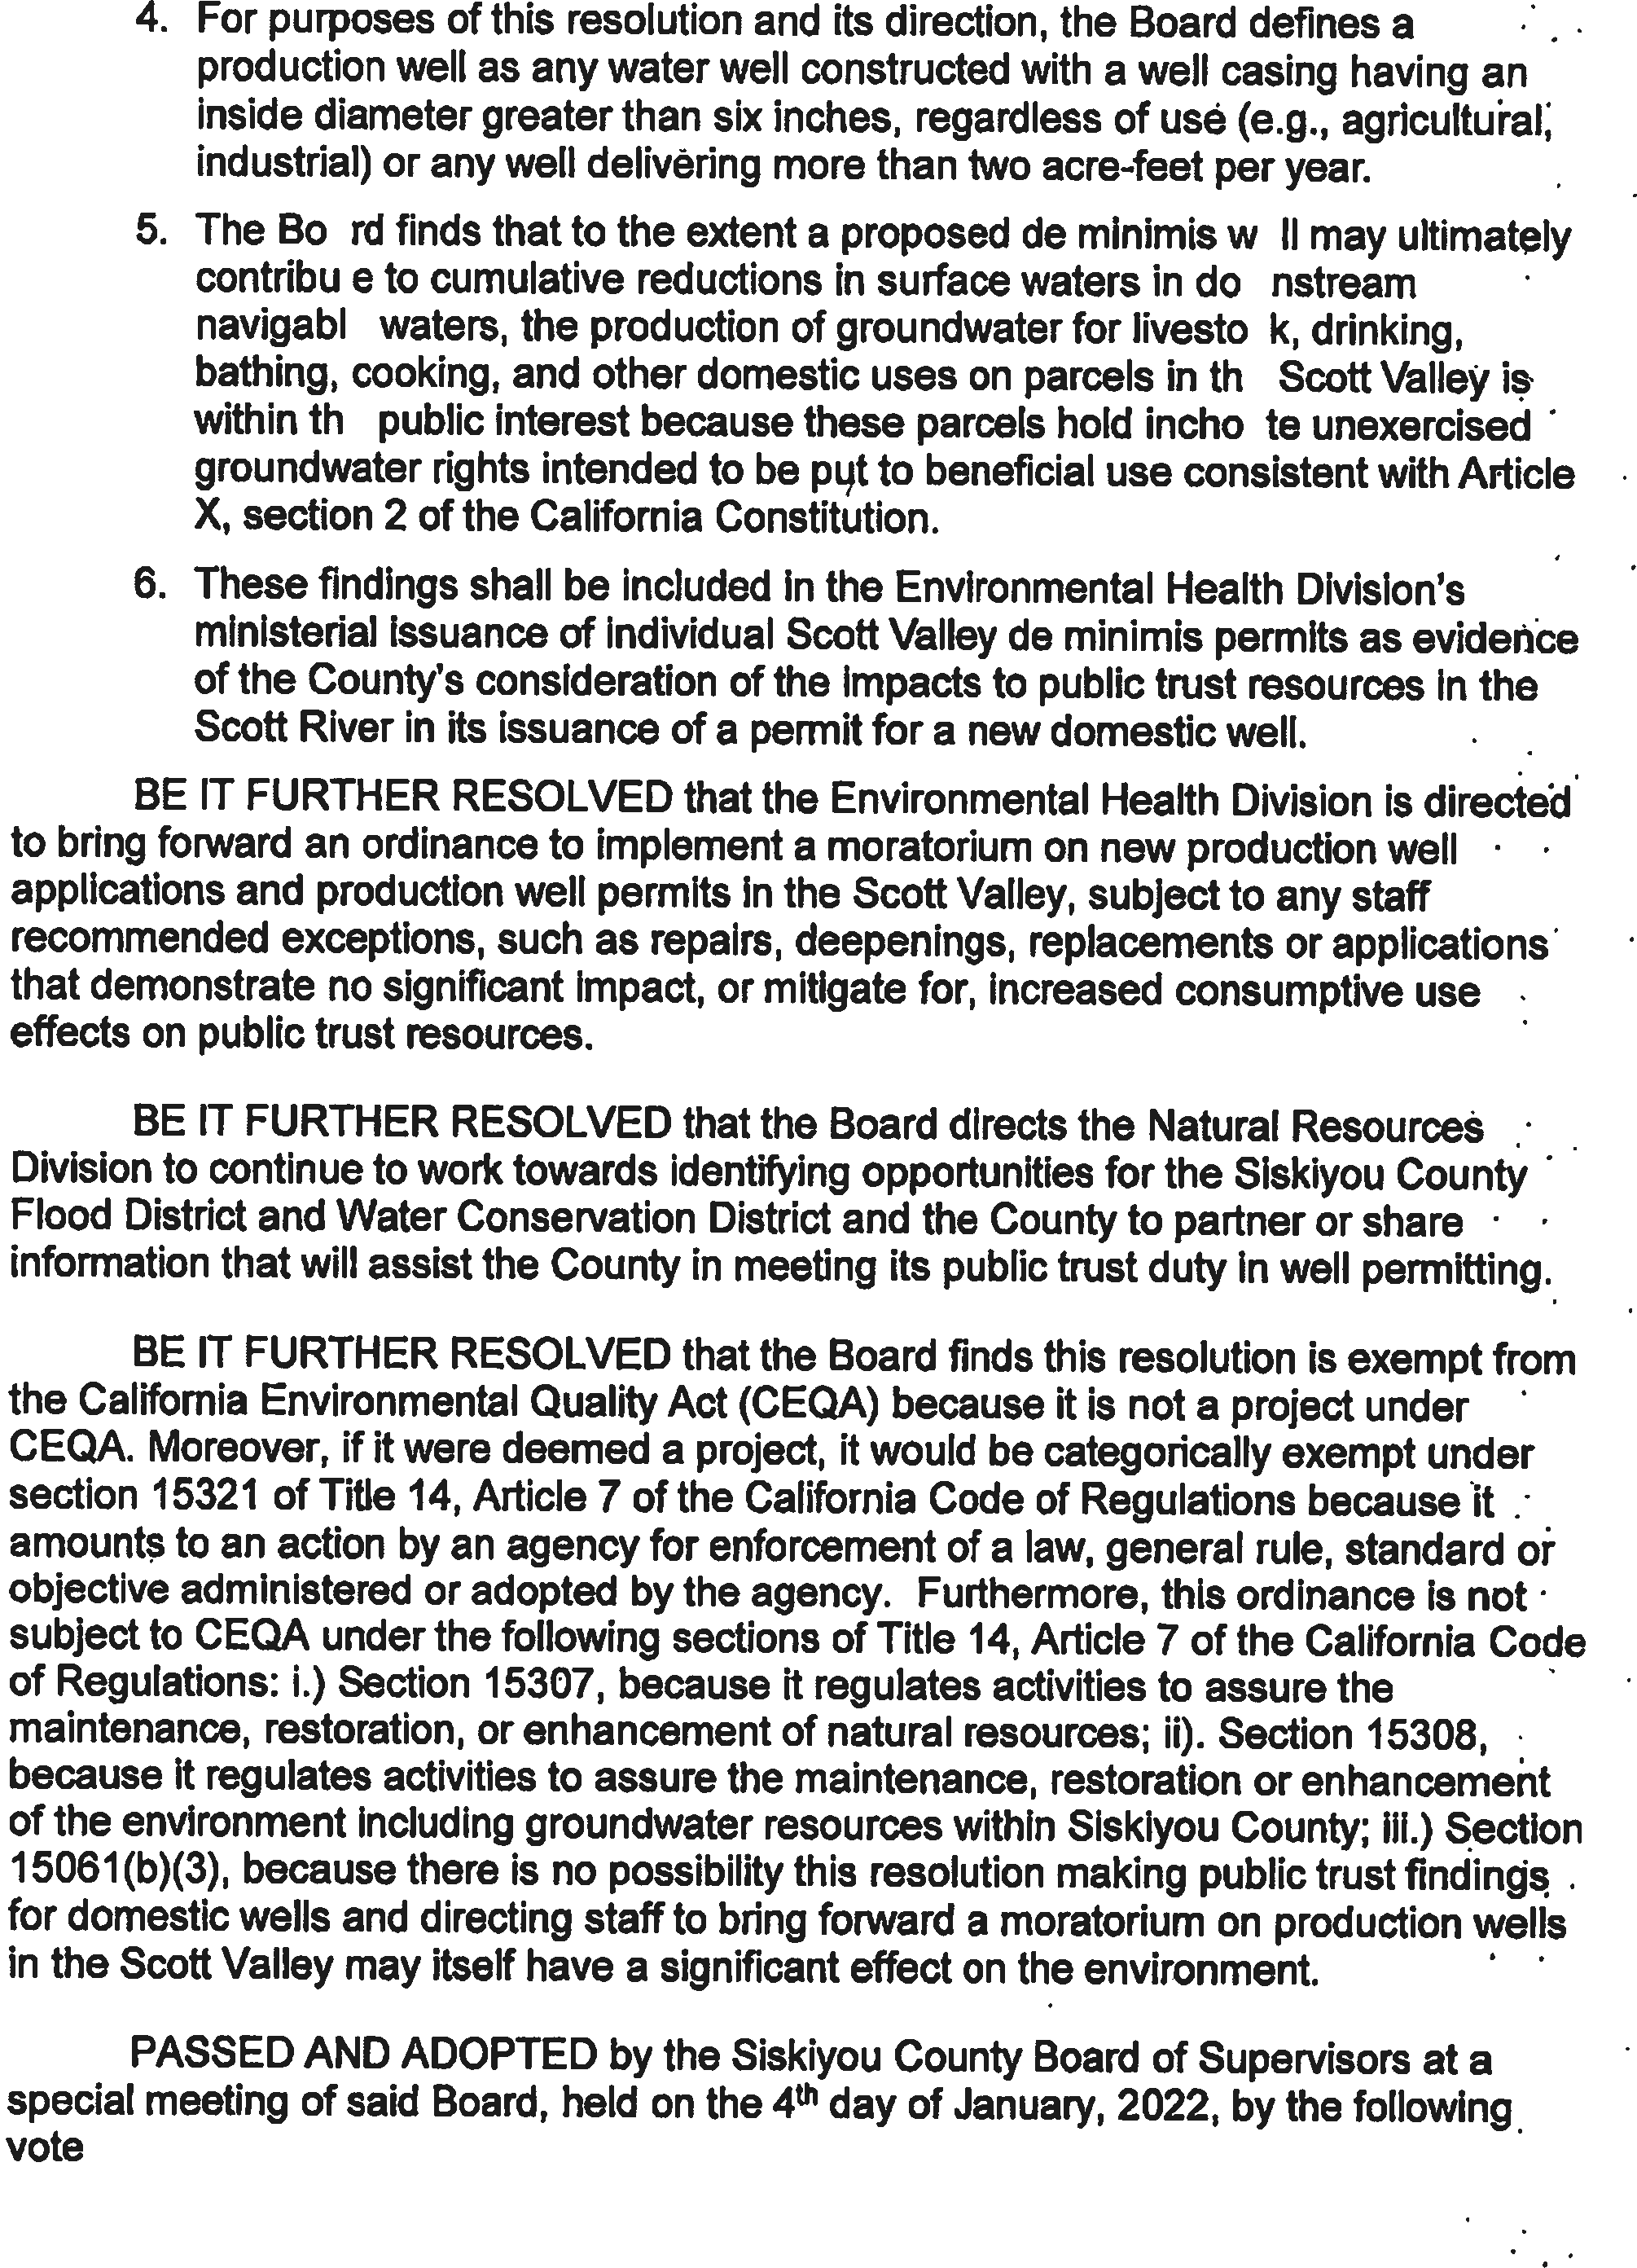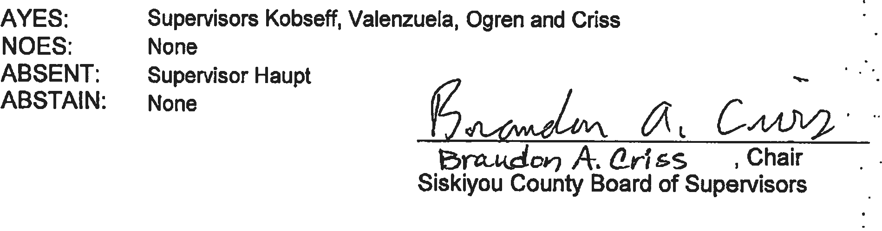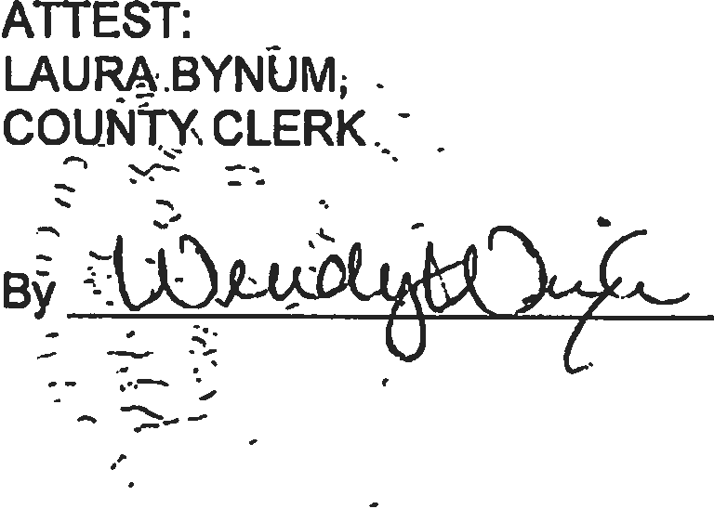

1.
2. The Third District Court of Appeal found the County’s obligations under the public trust doctrine in the Scott River watershed arose because the County is a subdivision of the state.
3. The Siskiyou County Flood Control and Water Conservation District serves as the Groundwater Sustainability Agency for the Scott, Shasta, and Butte Valley groundwater subbasins and reviews and provides verfications for production wells in these subbasins.

   The Tulelake Irrigation District serves as the Sustainability Plan Manager for the multi-agency Tulelake Subbasin Groundwater Sustainability Agency, and reviews and provides verifications for production well applications in this subbasin.
4. In the future, Environmental Health would like to explore with LWA the possibility of creating a defined Public Trust Review Area (PTRA) for the Scott and Shasta rivers based on best available data, which may streamline permitting. The PTRA would establish both lateral and vertical boundaries within the portion of the interconnected zone that identifies areas with moderate to high risk of impacts to Public Trust resources due to present day groundwater pumping.